**AI BASED DIABETES PREDICTION SYSTEM**

**Introduction:**

Diabetes is a chronic medical condition that affects millions of people worldwide. It is characterized by elevated blood sugar levels, which can lead to a variety of health complications if not properly managed. Early diagnosis and management of diabetes are essential to mitigate these risks. Artificial Intelligence (AI) has emerged as a promising tool in the field of healthcare, including the prediction and management of diabetes.

AI-based diabetes prediction systems leverage advanced algorithms and machine learning techniques to assist in the early detection of diabetes, potentially improving patient out Logistic Regression: A good starting point for binary classification problems, like predicting diabetes.

**Design Thinking Process:**

Designing an AI-based diabetes prediction system involves a multi-step process that incorporates Design Thinking principles to ensure the system meets the needs of users and effectively addresses the problem at hand. Here's a simplified version of the process:

**1. Empathize:**

- Identify the target audience: Understand the key stakeholders, including potential users, healthcare professionals, and researchers.

- Conduct interviews, surveys, and observations to gather insights about the diabetes prediction problem and the needs of users.

**2. Define:**

- Define the problem statement: Clearly articulate the problem you aim to solve, such as "How might we create an AI system that predicts diabetes risk?"

- Establish specific goals and success criteria for the AI-based system.

**3. Ideate:**

- Brainstorm solutions: Collaborate with a diverse team to generate a wide range of ideas on how to build the diabetes prediction system.

- Encourage creative thinking and consider various AI techniques, data sources, and features.

**4. Prototype:**

- Create a low-fidelity prototype: Develop a simplified version of the system to visualize the concept. It can be a paper sketch, wireframe, or a simple mockup of the user interface.

- Use AI tools and frameworks to create a basic model for diabetes prediction.

**5. Test:**

- Gather feedback: Share the prototype with potential users and stakeholders to obtain their insights and feedback.

- Use this feedback to refine and iterate on the prototype and the AI model.

**6. Develop:**

- Build the AI model: Once you have a well-defined concept and have received positive feedback, start developing the actual AI model using the selected algorithms and data sources.

- Ensure that the system is capable of making accurate diabetes risk predictions.

**7. Test (again):**

- Test the AI model rigorously using historical data and validation datasets.

- Fine-tune the model to enhance its predictive accuracy and reliability.

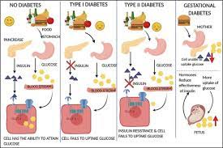

**8. Implement:**

- Integrate the AI system into the healthcare environment, whether it's a mobile app, web platform, or part of electronic health records (EHR) systems.

- Ensure that data privacy and security standards are met.

**9. Monitor and Evaluate:**

- Continuously monitor the AI system's performance and gather real-world user feedback.

- Evaluate the system's impact on diabetes prevention and management.

**10. Iterate:**

- Use ongoing user feedback, new research findings, and advances in AI to refine and improve the system over time.

- Be prepared to make adjustments and updates to the AI model and the user interface.

**Dataset:**

The dataset can be taken from the following below link,

**Dataset link:https://www.kaggle.com/datasets/mathchi/diabetes**

This dataset can be used for the process of diabetes prediction using AI. This dataset can includes the glucose level, pressure and some medical analysis for the prediction.

**Data Collection And Preprocessing:**

Collecting data for an AI-based diabetes prediction system is crucial for building a robust and accurate model. You can gather data from various sources, including electronic health records, surveys, wearable devices, and research studies**.**

Data preprocessing is a crucial step in preparing your data for an AI-based diabetes prediction system. Proper data preprocessing ensures that the data is clean, consistent, and ready for training machine learning models.

**Program:**

import numpy as np

import matplotlib.pyplot as plt

from sklearn.preprocessing import scale, StandardScaler

from sklearn.model_selection import train_test_split, GridSearchCV, cross_val_score

from sklearn.linear_model import LogisticRegression

from sklearn.linear_model import LogisticRegression

from sklearn.svm import SVC

from sklearn.neural_network import MLPClassifier

from sklearn.tree import DecisionTreeClassifier

from sklearn.ensemble import RandomForestClassifier

from sklearn.ensemble import GradientBoostingClassifier

from lightgbm import LGBMClassifier

from sklearn.model_selection import KFold

import warnings

warnings.simplefilter(action = "ignore")

from sklearn.model_selection import KFold

import warnings

warnings.simplefilter(action = "ignore")

df = pd.read_csv("/content/diabetes.csv")

df.head()

**output:**

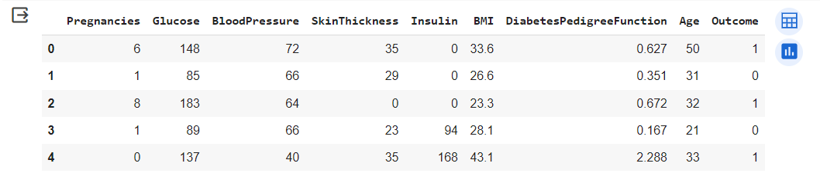

df.info()

**output:**



df.describe([0.10,0.25,0.50,0.75,0.90,0.95,0.99])

**output:**

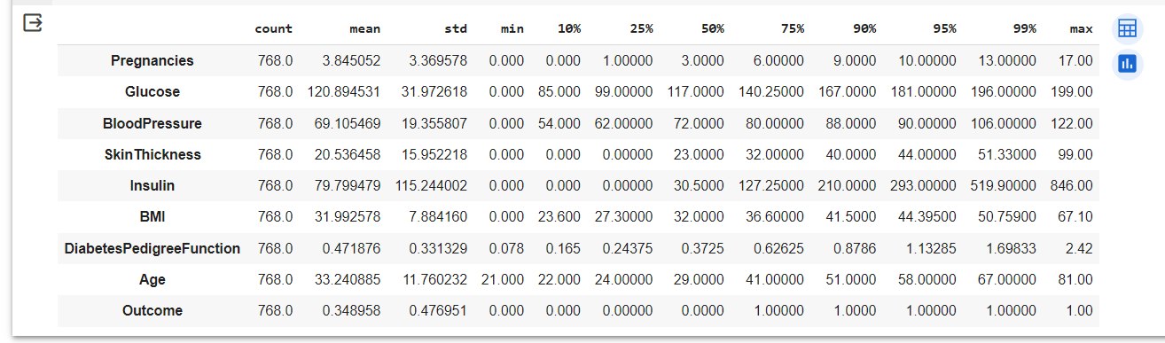

diabetes_dataset['Outcome'].value_counts()

**output:**

0 500

1 268

Name: Outcome, dtype: int64

X_train, X_test, Y_train, Y_test = train_test_split(X,Y, test_size = 0.2,

stratify=Y, random_state=2)

print(X.shape, X_train.shape, X_test.shape)

**output:**

(768, 8) (614, 8) (154, 8)

classifier = svm.SVC(kernel='linear')

classifier.fit(X_train, Y_train)

**output:**

|  |
| --- |
| SVC  SVC(kernel='linear') |

input_data = (5,166,72,19,175,25.8,0.587,51)

input_data_as_numpy_array = np.asarray(input_data)

input_data_reshaped = input_data_as_numpy_array.reshape(1,-1)

prediction = classifier.predict(input_data_reshaped)

print(prediction)

if (prediction[0] == 0):

print('The person is not diabetic')

else:

print('The person is diabetic')

**output:**

[1]

The person is diabetic

/usr/local/lib/python3.10/dist-packages/sklearn/base.py:439: UserWarning: X does not have valid feature

names, but SVC was fitted with feature names warnings.warn(

**Conclusion:**

In conclusion, AI has the potential to transform the management of diabetes by enabling early detection, personalized treatment, and improved patient engagement. It also plays a crucial role in accelerating research and drug discovery. However, it's important to address privacy and security concerns, ensure data accuracy, and involve healthcare professionals in AI-assisted decision-making to maximize the benefits of AI in diabetes care.